**JavaScript Assignment : Compound Interest Calculation (Task 10)**

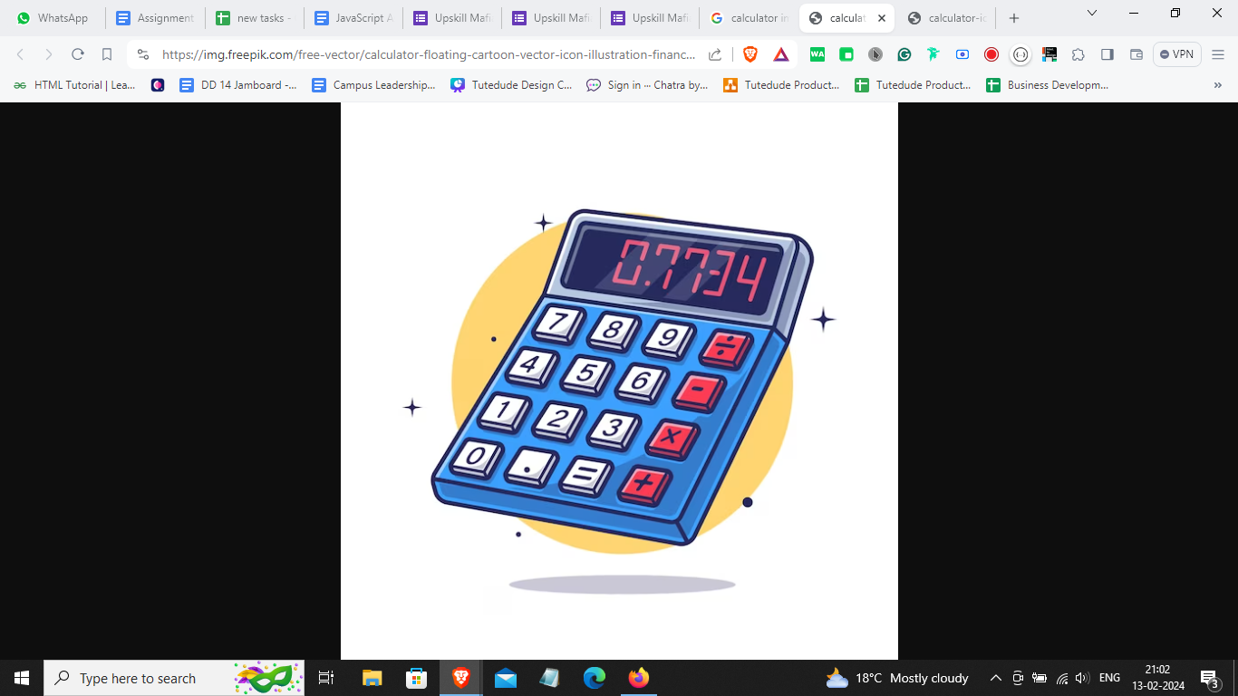

**Objective:** The objective of this assignment is to create a JavaScript program that calculates compound interest based on static values.

**Tasks:**

Write a JavaScript program that calculates compound interest.

Use variables and operators.

Formula for Compound Interest:

The formula to calculate compound interest is as follows:

A=P(1+(r/n))^nt

**Where:**

* A = amount
* P = principal
* r = rate of interest
* n = number of times interest is compounded per year
* t = time (in years)

**Instructions:**

Implement the formula for compound interest using predefined variables.

Display the calculated compound interest to the user using console.log() .

**Sample Output:**

The compound interest after 3 years is: 50000

**Submission Guidelines :-**

* Deploy your code to netlify make sure to name your html file as index.html.
* If you don’t know how to deploy on netlify, watch this video : <https://youtu.be/Ii2Y4i4_i-o>
* Submit the Deployed Link below in the same task number

Submission Link : [https://upskillmafia.com/mern/dashboard/tasks](http://upskillmafia.com/mern/dashboard/tasks)

| **Note :** You can take help from **Internet** or You can also connect with upskill Mafia **Mentors** |
| --- |